Ernest (Jiachang) Xu

CSCI 485: File and Database System

Assignment #1: Conceptual and Logical Data Modeling

1 Feb. 2018

**Conceptual Data Modeling**

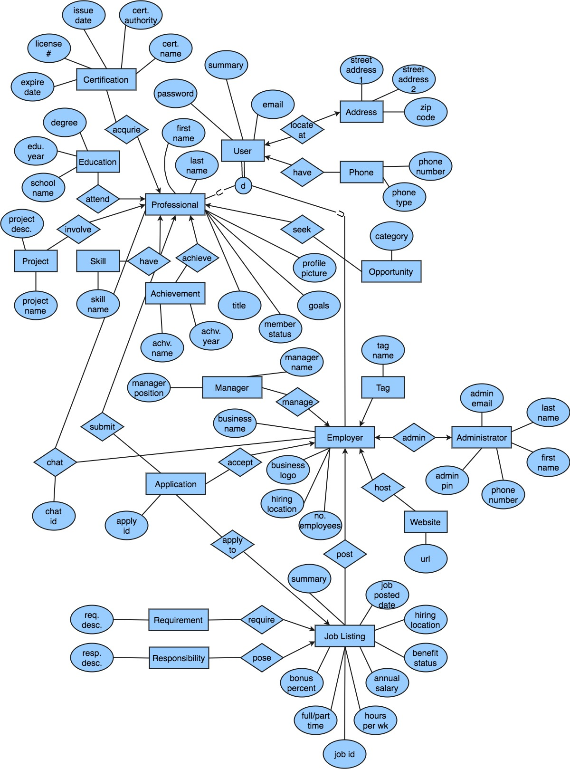

**Logical Data Modeling**

*User* (**userEmail**, password, summary)

*Professional* (**professionalEmail**, lastName, firstName, title, goals, profilePicture, memberStatus)

*Employer* (**employerEmail**, businessName, businessLogo, #employees, hiringLocation, adminEmail)

*Administrator* (**adminEmail**, adminPIN, employerEmail, lastName, firstName, phoneNumber)

*Phone* (**userEmail**, **phoneNumber**, phoneType)

*Address* (**userEmail**, **streetAdderss1**, **streetAddress2**, **zip**)

*Achievement* (**professionalEmail**, **achvName**, **achvYear**)

*Skill* (**professionalEmail**, **skillName**)

*Project* (**professionalEmail**, **projName**, projDesc)

*Education* (**professionalEmail**, **degree**, **schlName**, eduYear)

*Tag* (**employerEmail**, **tagName**)

*Website* (**employerEmail**, **url**)

*Job_Listing* (**employerEmail**, **jobID**, jobPostDate, hiringLocation, benefitStatus, annualSalary, hoursPerWeek, fullPartTime, bonusPercent, summary)

*Requirement* (**jobID**, **reqDesc**)

*Responsibility* (**jobID**, **respDesc**)

*Chat* (**chatID**, professionalEmail, employerEmail)

*Application* (**applyID**, professionalEmail, employerEmail, jobID)

*Opportunity* (**professionalEmail**, **category**)

*Certification* (**professionalEmail**, **license#**, certName, certAuthority, issueDate, expireDate)

**Normalization**

* Second Normal Form
  + No normalization applied under the Second Normal Form.
* Third Normal Form
  + The *Address* table complies with the Third Normal Form. Usually a writtenr address includes city and state in addition to what I have in the *Address* table. However, city and state are both facts about the non-key attribute zip code. Therefore, I only include zip code in the *Address* table, which can be used as search key to find its corresponding city and state from an online database (i.e. USPS).
* Fourth Normal Form
  + A professional may have multiple phone numbers, may achieve several achievements, may have multiple skills, may involve in multiple project, may attend multiple education degrees, and may acquire multiple certifications, which are all independent of each. Therefore, I have created separate tables, such as *Phone*, *Achievement*, *Skill*, *Project*, *Education*, and *Certification*, to comply with the Fourth Normal Form
  + An employer may post multiple job listings. Therefore, I have created a separate table for *Job_Listing*, to comply with the Fourth Normal Form.
  + A job listing may have multiple clauses of responsibilities, and may have multiple clauses of requirements, which are both independent of each other. Therefore, I have created separate tables for *Responsibilities* and *Requirements*.